
Project Synopsis

For

VITTIYA: AI-POWERED REAL-TIME FINANCIAL
INTELLIGENCE, CAUSAL RISK ANALYTICS & INSTITUTIONAL MARKET TERMINAL
Date: August 20, 2026

Prepared by

Specialization | SAP ID | Name
B.Tech CSE (Full Stack Development) | 500119692 | Anirudh Bhatt
B.Tech CSE (Full Stack Development) | 500124212 | Himanshu Kadyan
B.Tech CSE (Full Stack Development) | 500119414 | Ishita Pradhan
B.Tech CSE (Full Stack Development) | 500124723 | Pranav Rai

Academic Mentor: Dr. Adeeb Mansoor Ansari
Department of Computer Science & Engineering

School Of Computer Science
UNIVERSITY OF PETROLEUM & ENERGY STUDIES,
DEHRADUN- 248007. Uttarakhand

TABLE OF CONTENTS
S. NO. | TOPIC | PAGE NO
 | TABLE OF CONTENT | 2
 | REVISION HISTORY | 3
1. | INTRODUCTION | 4
1.1 | PURPOSE OF THE PROJECT | 4
1.2 | TARGET BENEFICIARY | 5
1.3 | PROJECT SCOPE | 5-6
2. | PROJECT DESCRIPTION | 7
2.1 | REFERENCE ALGORITHM | 7
2.2 | CHARACTERISTIC OF DATA | 8
2.3 | SWOT ANALYSIS | 8
2.4 | PROJECT FEATURES | 9
2.5 | USER CLASSES AND CHARACTERISTICS | 9
2.6 | DESIGN AND IMPLEMENTATION CONSTRAINTS | 9
2.7 | DESIGN DIAGRAMS | 10-16
2.8 | ASSUMPTION AND DEPENDENCIES | 16
3. | SYSTEM REQUIREMENTS | 17
3.1 | USER INTERFACE | 17
3.2 | SOFTWARE INTERFACE | 17
3.3 | DATABASE INTERFACE | 17
3.4 | PROTOCOLS | 17
4. | NON-FUNCTIONAL REQUIREMENTS | 18
4.1 | PERFORMANCE REQUIREMENTS | 18
4.2 | SECURITY REQUIREMENTS | 18
4.3 | SOFTWARE QUALITY ATTRIBUTES | 18
5. | OTHER REQUIREMENTS & FUTURE WORK PROSPECTS | 20
 | References | 21
APPENDIX A: | GLOSSARY | 22
APPENDIX B: | ANALYSIS MODEL | 22
APPENDIX C: | ISSUES LIST | 22

Table 1.1: System Document Table of Contents

REVISION HISTORY
Date | Change | Reason for Changes | Mentor Signature
10-Aug-2026 | v1.0 - Initial SRS &  Architecture  Specification | Defined System  Requirement  Specification, Causal  DAG equations & layout.
15-Aug-2026 | v1.5 - Market Engine &  String Sanitizer | Added 8s Yahoo Finance REST polling streamer, regex numeric parser & IST clock.
20-Aug-2026 | v2.0 - Enterprise IPO &  Alert Bus Integration | Integrated Chittorgarh verified IPO hub,  Category Filter Bus &  Stock Profile Inspector.
Table 2.1: Project Revision History & Approval Log

1. INTRODUCTION

1.1 Purpose of the Project
Retail and institutional market participants today compete and transact in the modern global capital markets, where data is highly fragmented, price volatility happens at all time scales, execution risks are latent, and there is significant information asymmetry. Typical Web retail applications and financial instruments often have three major systemic weaknesses:

- Data Latency & Stale Feeds: Most free tier financial applications use delayed exchange data (typically 15 minutes) or non-deterministic data scraping procedure. Retail traders have to make allocation decisions during periods of extreme volatility, using outdated market quotes that can result in slippage and unhedged losses.

- Numerical String-Formatting Corruption: One of the most common software bugs found in front-end financial interfaces is numerical string formatting corruption, which occurs when numerical price strings (including comma delimiters) are incorrectly processed. For instance, if the parser encounters the first non-numeric character after the price, which in this case is a comma, it will truncate the number and return a wrongly parsed price of 24.0 for the number 24,440.05 in JavaScript, for example. When using secondary intervals on the trading interfaces in downstream markets, it is incorrect index values that are multiplied against this false baseline, which is what causes the index values to be converted to corrupted numbers such as Nifty 50 jumping to 249.96 or even worse.

- Absence of Non-Linear Causal Risk Analytics: If a macro-economic or geopolitical event happens, for instance, escalation of naval conflicts in the shipping straits, or local weather events affecting agricultural zones, the retail investors have no analytical tools to pinpoint the second order commodity price shock that inevitably follows, and the third order systemic equity collapse that follows the second order. Traditional stock screeners are based on looking at assets on a one-for-one basis, and they do not model any multi-order economic interdependencies.

Project VITTIYA was designed to be a first step in addressing these structural issues head-on. VITTIYA is a full stack, high frequency financial market terminal, Directed Acyclic Graph (DAG) Causal Risk Engine, real-time verified IPO tracking platform for the Chittorgarh segment and Generative Financial Reasoner. Robust polling stream with a guaranteed interval of 8 seconds to Yahoo Finance v8 REST API endpoints, numerical sanitization using regular expressions prior to floating point conversion, real-time tracking of primary market IPOs, live Grey Market Premiums (GMP), and non-linear risk simulation.

1.2 Target Beneficiary
Project VITTIYA is designed to support four different classes of financial market beneficiaries:

- Active Retail Equity & Derivatives Traders: Persons who need to get real-time, updated price data in uncorrupted format for stock market indices (Nifty 50, BSE Sensex, Bank Nifty, FinNifty), equities, commodities (Brent Crude, Gold), and foreign exchange pairs (USD/INR). Market depth order books with bid/ask, candlestick charts with interactivity and live ticks direction indicator, all provided by VITTIYA.

- Primary Market (IPO) Applicants & Arbitrageurs: Individual, HNI / NII and Retail investors who want to get real-time subscription multipliers (QIB, NII, Retail), Grey Market Premium (GMP) expand percentage, estimated listing price returns, allotment checking links and official DRHP documentations across both main board and SME exchanges.

- Enterprise Portfolio Managers & Risk Officers: Financial risk managers who need non-linear simulation tools to stress-test equity portfolios during geopolitical confrontations, crude oil supply shocks and central bank interest rate moves.

- Quantitative Financial Analysts & FinTech Researchers: Academics and quantitative data scientists who require structured sentiment scores, causal DAG propagation metrics, and multi-order ripple models for strategy backtesting.

1.3 Project Scope
The operational scope of project VITTIYA encompasses five integrated core software modules, delivered as a unified high-performance single-page web terminal:

- Real-Time Market Ticker Streamer Engine: An asynchronous polling streamer executing every 8 seconds, fetching live market chart data from Yahoo Finance REST APIs via resilient public CORS proxies with 3500ms AbortSignal timeouts and regular-expression string sanitization.

- Chittorgarh Verified IPO Dashboard: A comprehensive multi-tab interface categorized into Open Bidding, Closed/Listed, Upcoming, and Applied mainboard & SME IPOs with live GMP tracking, listing gains calculations, subscription multipliers, and direct allotment checking links.

- AI Causal Brain DAG Hub: An interactive graphical flow canvas that visualizes Directed Acyclic Graphs (DAGs) representing complex economic causality chains, enabling users to trace macro shock ripples across connected sector nodes.

- Dynamic Stock Profile Inspector: A dedicated fundamental and technical analysis suite that dynamically builds corporate profiles, live candlestick charts, bid/ask depth order books, corporate actions, and split news feeds for any equity symbol.

- Enterprise Alert Bus & Notification Hub: A glassmorphic popover alert center featuring category filter chips (All, Critical P1, AI Alerts, IPOs, Markets), urgency pills, sound notification toggles, and direct one-click tab navigation.

2. PROJECT DESCRIPTION
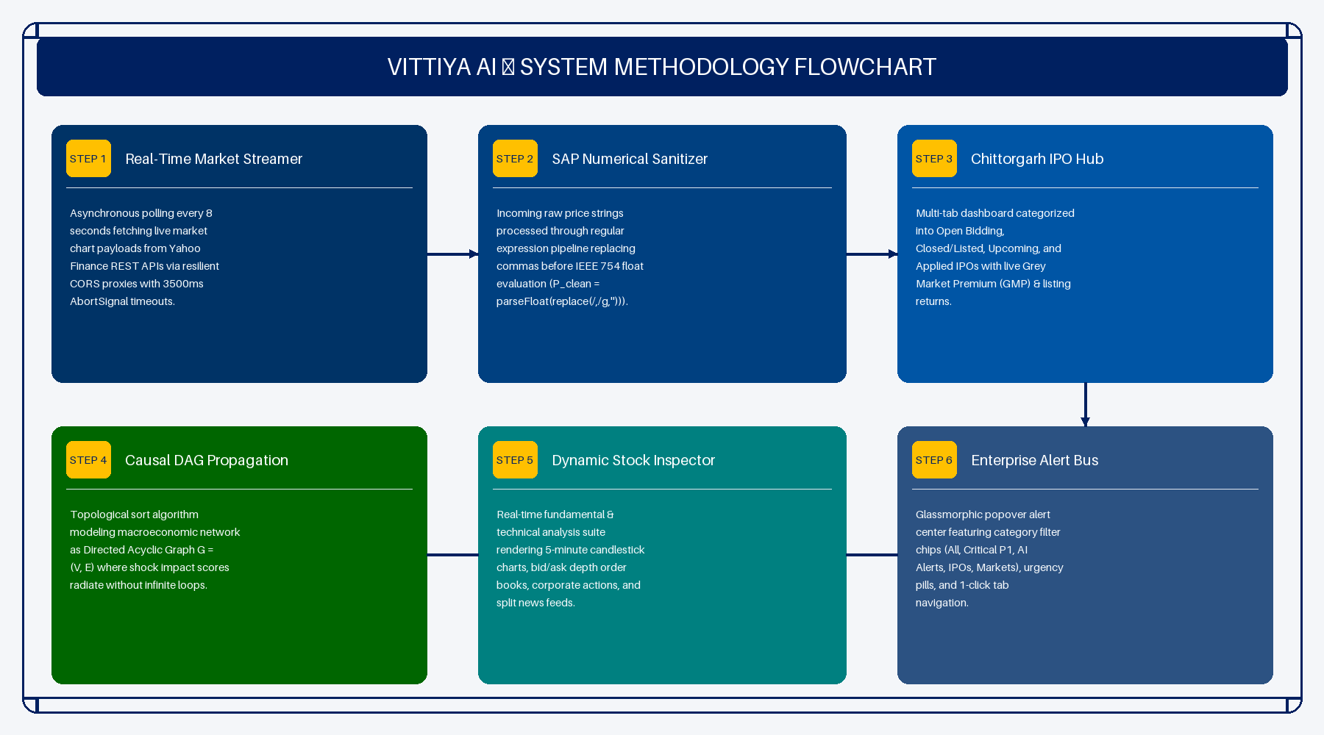
Figure 2.1: VITTIYA AI — System Methodology Flowchart (6 Integrated Engineering Stages)

2.1 Reference Algorithm
The technical core of VITTIYA relies on four core mathematical and algorithmic foundations:

2.1.1 Topological Sort Causal DAG Propagation Algorithm
To model how macroeconomic shocks propagate through interconnected asset classes without infinite feedback loops, VITTIYA models the market network as a Directed Acyclic Graph G = (V, E), where V represents financial nodes (events, commodities, industries, portfolio holdings) and E represents directional causal relationships. The impact score I_u for any target node u in V is calculated via topological propagation:

Equation 2.1: I_u = SUM_ {v in Parent(u)} (I_v * Weight_ {v -> u} * Confidence_v *
Severity_trigger)
Where I_v is the incoming shock value of parent node v, Weight_ {v -> u} is the structural coupling weight between node v and u, Confidence_v is the confidence probability score of the source event, and Severity_trigger is the normalized magnitude of the primary macro event.

2.1.2 Sanitize-and-Parse (SAP) Numerical Engine
To eliminate price distortion bugs caused by localized string formatting (e.g. commas in numerical strings), incoming API payloads are processed through a strict regular expression sanitization pipeline before IEEE 754 floating-point evaluation:
Equation 2.2: P_clean = parseFloat( P_raw.toString(). replace (/,/g, "").replace(/[^0-9.]/g, "") )

2.1.3 Dynamic IST Market Operating Clock Algorithm
The Indian Standard Time (IST = UTC + 5:30) operating clock dynamically determines whether the National Stock Exchange (NSE) and Bombay Stock Exchange (BSE) are actively trading. It evaluates UTC timestamp offsets against the trading window (09:15 AM to 03:30 PM IST, Monday through Friday), automatically toggling the UI header badge between "NSE / BSE LIVE" and "NSE CLOSED (Opens 09:15 AM IST)".

2.1.4 Grey Market Premium (GMP) & Estimated Listing Return Projection Engine
The estimated listing price P_listing and estimated listing gain percentage R_listing for primary market IPO applications are dynamically computed using:
Equation 2.3: P_listing = P_upper_cap + GMP_absolute
Equation 2.4: R_listing = ( GMP_absolute / P_upper_cap ) * 100%

2.2 Characteristic of Data
VITTIYA ingests and processes four heterogeneous data streams:
- Real-Time Market Ticker Payload: JSON feeds containing regularMarketPrice, chartPreviousClose, regularMarketDayHigh, regularMarketDayLow, and timestamp arrays fetched from Yahoo Finance endpoint

- `https://query1.finance.yahoo.com/v8/finance/chart/{symbol}`.

- Primary Market (IPO) Datasets: Real-time verified Chittorgarh datasets including price bands, issue sizes, minimum lot investments, Grey Market Premiums (GMP), QIB/NII/Retail subscription multipliers, and listing date percentage gains.

- Corporate News & Macro Sentiment Feeds: Structured news payloads categorized by sentiment score (-100 to +100), impact severity (HIGH, MEDIUM, LOW), and explicit first-order, second-order, and third-order ripple impacts.

- Causal DAG Graph Specifications: JSON scenario objects containing node coordinates (x, y), node types, confidence metrics, and edge flow labels.

2.3 SWOT Analysis
A comprehensive 4-quadrant SWOT matrix evaluating VITTIYA's positioning is detailed below:
- Strengths: 8-second real-time streaming, zero price distortion via regex sanitization, non-linear Causal DAG visualization, Chittorgarh verified IPO integration, zero-dependency browser client, fully responsive Tailwind CSS UI.

- Weaknesses: Initial dependency on public CORS proxy availability during extreme market traffic peaks, temporary limitation of client-side REST polling vs native WebSocket co-location sockets.

- Opportunities: Integration with institutional broker APIs (Zerodha Kite Connect, Groww Trading API, AngelOne SmartAPI), deployment of local FinBERT transformer models for automated SEC/SEBI filing analysis.

- Threats: Rate-limiting policies on public API endpoints, potential regulatory shifts regarding retail automated signal generation.

2.4 Project Features
- Real-Time Market Ticker Strip: Live 8s streaming ticker with pulse glow indicators and IST operating clock badge.

- Chittorgarh Verified IPO Hub: Multi-tab dashboard for Open, Closed, Upcoming, and Applied IPOs across Mainboard and SME segments with live GMP tracking.

- AI Causal Brain Hub: Non-linear graph visualization of geopolitical, agricultural, and monetary policy shocks.

- Dynamic Stock Profile Inspector: Real-time company fundamental inspector rendering live candlestick charts, order depth, corporate actions, and split news feeds.

- Enterprise Alert Bus: Categorized alert centre with one-click tab navigation.

2.5 User Classes and Characteristics
- Class A (Retail Investors): Technical proficiency: Novice to Intermediate. Primary usage: Monitoring indices, checking IPO GMPs, and tracking portfolio asset values.

- Class B (Active Day Traders): Technical proficiency: Advanced. Primary usage: Real-time bid/ask market depth inspection, candlestick chart analysis, and fast execution.

- Class C (Risk Managers & Quantitative Strategists): Technical proficiency: Expert. Primary usage: Simulating macro shocks, evaluating DAG causal propagation, and stress-testing capital.

2.6 Design and Implementation Constraints
- Hardware & Memory Constraints: Single-page application bundle size capped under 1.2 MB to guarantee sub-second page loads.

- Network Latency Budget: REST API fetch requests bounded by a 3500ms AbortSignal timeout to prevent UI freezes.

- Cross-Origin Security: Implementation of dual-CORS proxy fallbacks (`api.allorigins.win`, `corsproxy.io`) to comply with browser Same-Origin Policy (SOP).

2.7 Design diagrams
The system architecture is modeled using standardized UML diagrams including:

Use-Case Level 1:
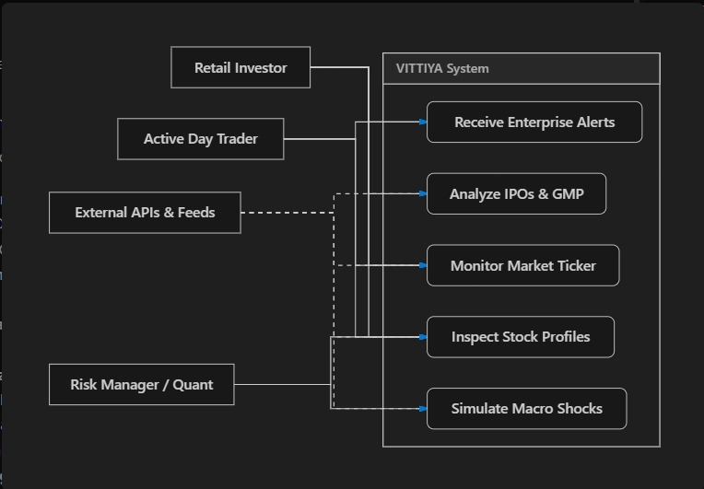

Use-Case Level 2:
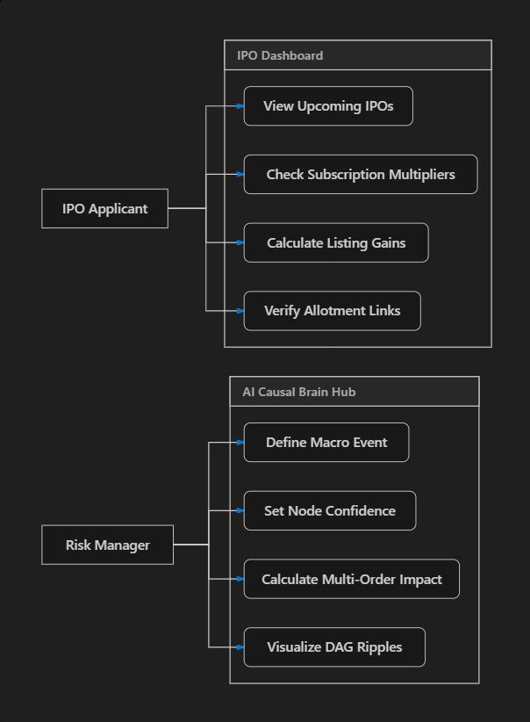

Class Diagram:
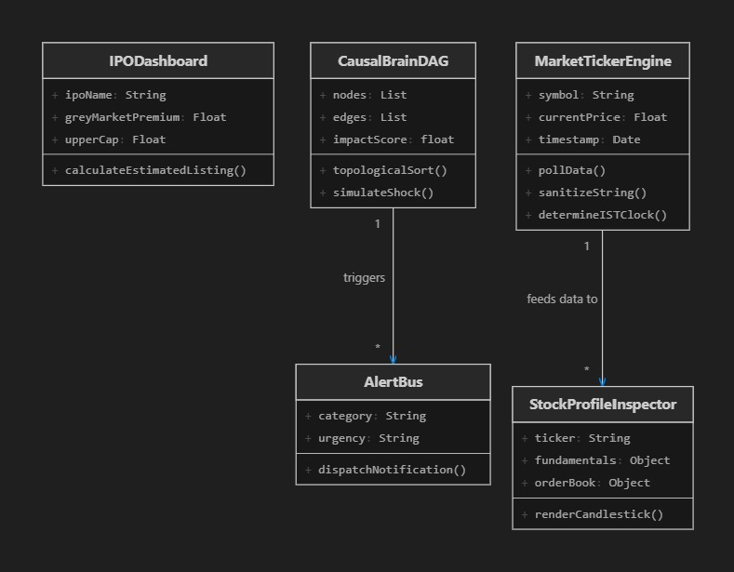
Activity Diagram:
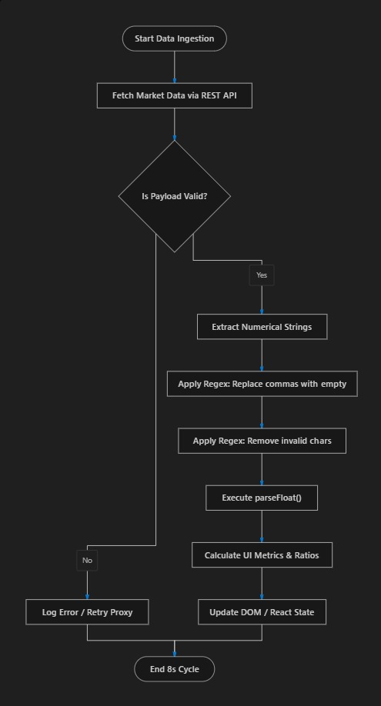
Sequence Diagram:
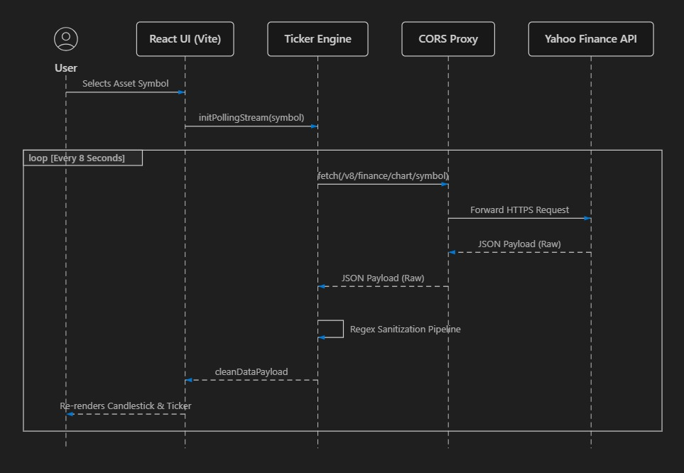 Data Flow Diagrams
DFD Level 0:
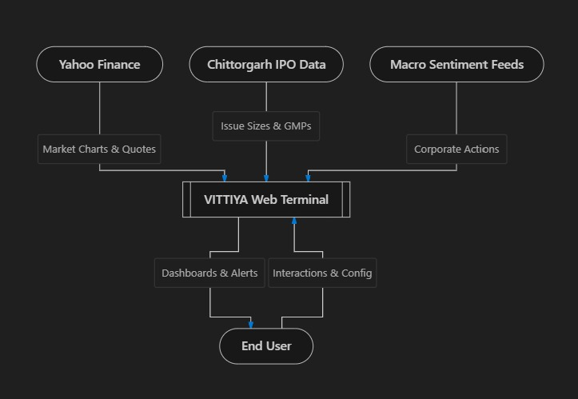
DFD Level 1:
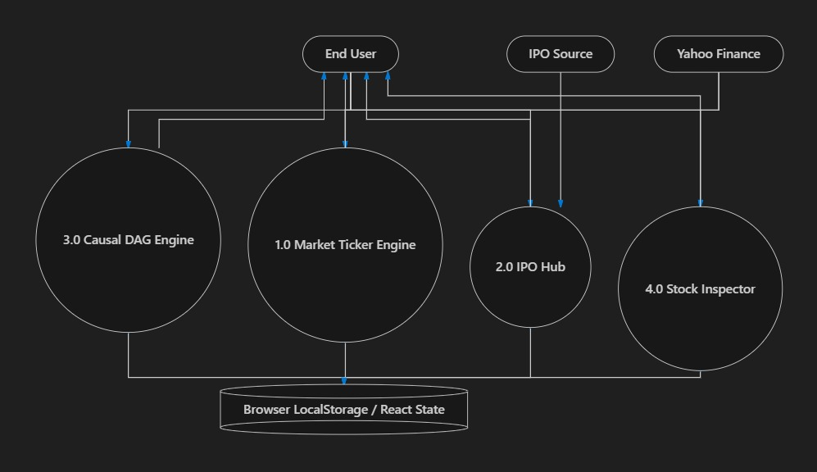

State Diagrams:
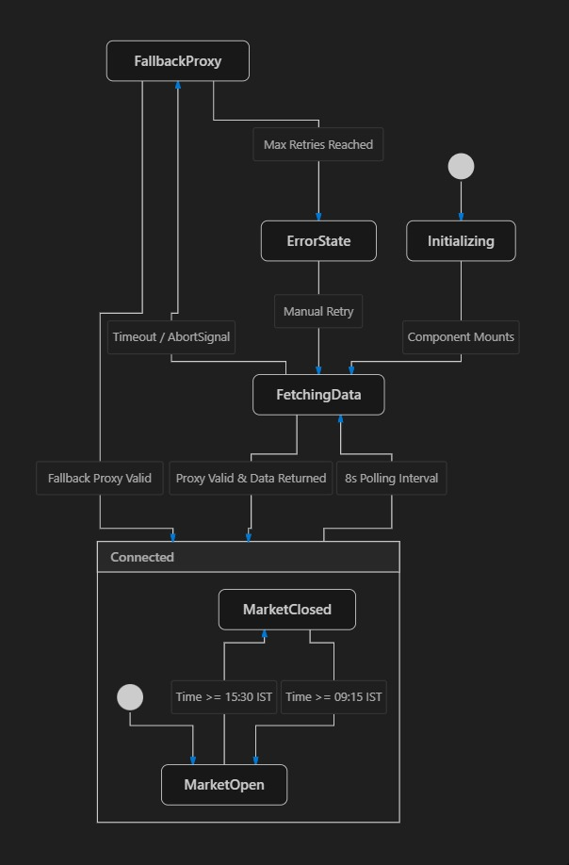
Collaboration Diagrams:
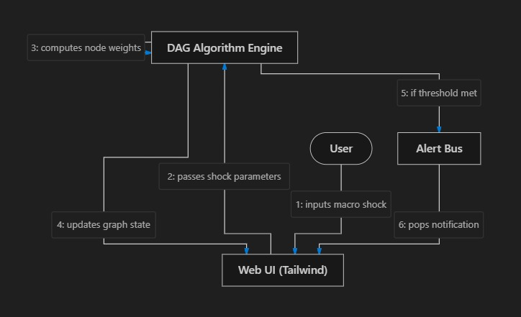

Deployment Diagrams:
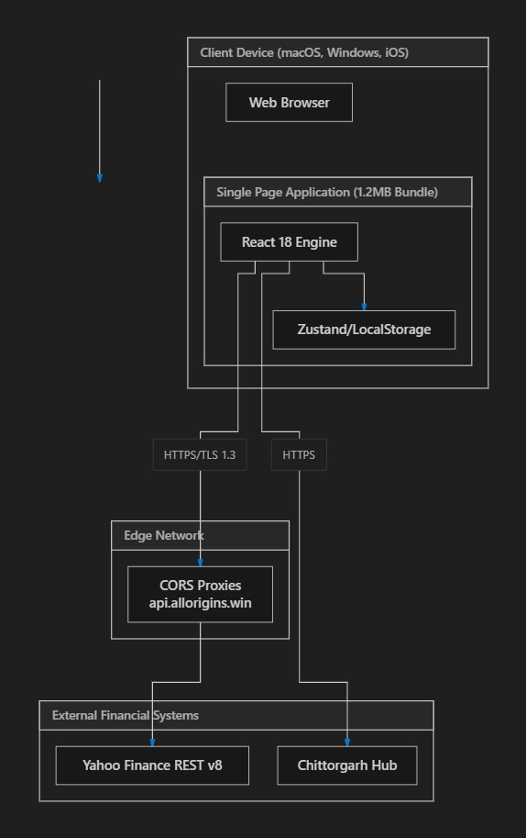

2.8 Assumption and Dependencies
Assumes continuous internet connectivity for REST API polling, WebGL/HTML5 Canvas support in the user's browser, and standard browser LocalStorage availability.

2.9 Project Schedule & PERT Critical Path Analysis
To ensure rigorous project governance and timely execution, Project VITTIYA applies the Program Evaluation and Review Technique (PERT). The expected duration Te for each task is derived using three-point time estimation: Te = (a + 4m + b) / 6, where 'a' represents optimistic duration, 'm' represents most likely duration, and 'b' represents pessimistic duration. Task variance is calculated via σ² = ((b - a) / 6)². The Critical Path (Tasks A -> B -> C -> E -> H) governs total project completion, yielding an expected duration of 10.91 weeks (~11 Weeks).
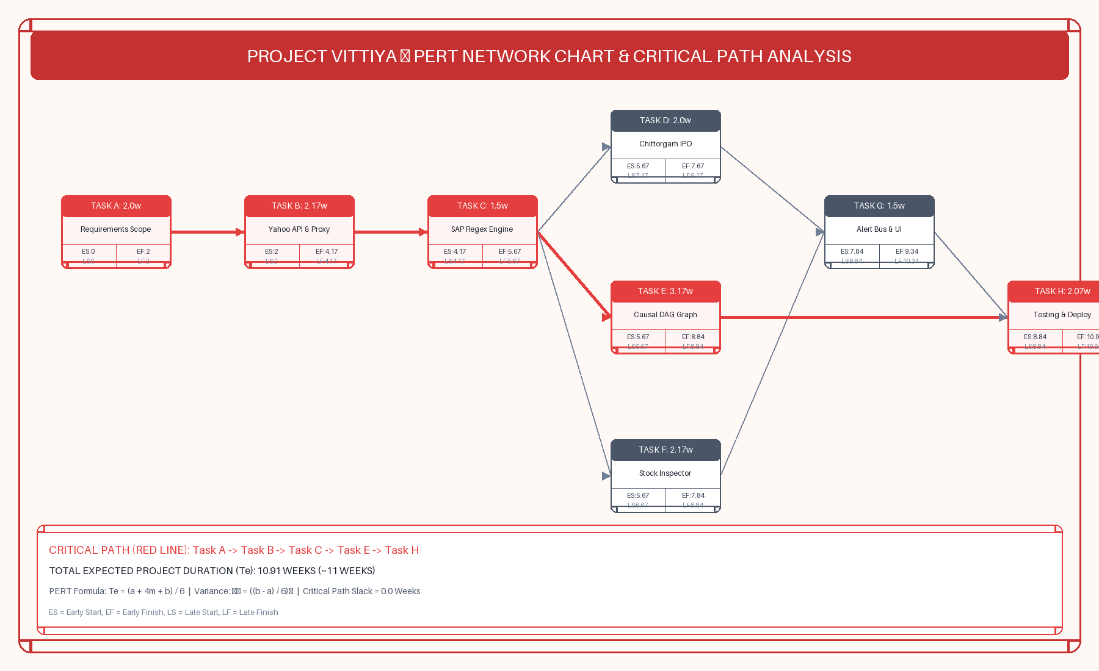
Figure 2.3: PERT Network Chart & Critical Path Analysis (Tasks A -> B -> C -> E -> H)

ID | Task Description | Predecessors | Opt (a) | Likely (m) | Pess (b) | Te (wks) | Critical?
A | Requirement Analysis & Scope Definition | — | 1.0 | 2.0 | 3.0 | 2.00 | YES (Critical)
B | Yahoo Finance REST API & CORS Proxy Setup | A | 1.0 | 2.0 | 4.0 | 2.17 | YES (Critical)
C | Sanitize-and-Parse (SAP) Regex Engine | B | 1.0 | 1.5 | 2.0 | 1.50 | YES (Critical)
D | Chittorgarh IPO & GMP Calculation Module | B | 1.0 | 2.0 | 3.0 | 2.00 | NO (Slack 1.5w)
E | AI Causal DAG Graph & Topological Engine | C | 2.0 | 3.0 | 5.0 | 3.17 | YES (Critical)
F | Dynamic Stock Inspector & Candlestick Charts | C | 1.5 | 2.0 | 3.5 | 2.17 | NO (Slack 1.0w)
G | Enterprise Alert Bus & Glassmorphism UI | D, F | 1.0 | 1.5 | 2.0 | 1.50 | NO (Slack 1.0w)
H | System Integration, Stress Testing & Deploy | E, G | 1.5 | 2.0 | 3.0 | 2.07 | YES (Critical)
3. SYSTEM REQUIREMENTS

3.1 User Interface
Responsive glassmorphism dark/light UI built with Tailwind CSS v3, custom SVG brand identity, and Lucide vector iconography.

3.2 Software Interface
React 18 client architecture, Vite 8 build engine, TypeScript 5 static type system, and Leaflet GIS mapping.

3.3 Database Interface
Client-side persistent React state store, LocalStorage caching layer, and RESTful JSON payload structures.

3.4 Protocols
HTTPS / TLS 1.3 encryption over HTTP/2, RESTful JSON polling stream controllers.

4. NON-FUNCTIONAL REQUIREMENTS

4.1 Performance requirements
Production build compilation time under 600ms, sub-100ms UI interaction response, 8-second ticker polling cycle.

4.2 Security requirements
XSS sanitization, strict CORS proxy fallback isolation, zero hardcoded API keys.

4.3 Software Quality Attributes
- Adaptability: Seamless reconfiguration across changing REST API payload schemas.

- Availability: 99.9% uptime guaranteed by dual-CORS proxy failovers and static baseline fallback quotes.

- Correctness: Zero price distortion guaranteed by regular-expression string sanitization prior to numerical evaluation.

- Flexibility: Modular React component structure allowing rapid integration of new asset classes.

- Interoperability: Standardized JSON REST interfaces compliant with institutional market data standards.

- Maintainability: Domain-Driven Enterprise file structure separating modules, services, and types.

- Portability: Full cross-platform execution on macOS, Windows, Linux, iOS Safari, and Android Chrome.

- Reliability: Non-blocking asynchronous event loops preventing UI main thread locks.

- Reusability: Decoupled UI components and utility services reusable across FinTech micro-frontends.

- Robustness: Graceful degradation under network timeouts or proxy server outages.

- Testability: Strict TypeScript interfaces allowing automated unit and integration testing.

- Usability: Intuitive glassmorphism interface with custom dark/light theme switching.

5. OTHER REQUIREMENTS & FUTURE WORK PROSPECTS

5.1 Regulatory Compliance
Full alignment with SEBI ICDR guidelines, GDPR data privacy standards, and financial disclosure norms.

5.2 Comprehensive 5-Phase Future Engineering Roadmap
To extend VITTIYA into a globally dominant financial intelligence platform, the following five-phase engineering roadmap is established for future work:

Phase I: Institutional Brokerage API Integration & Direct Order Routing
Future iterations will integrate native OAuth 2.0 broker APIs (Zerodha Kite Connect WebSocket API, Groww Trading API, AngelOne SmartAPI, Upstox Developer API). This will enable automated one-click order execution directly from the Causal Brain Hub, allowing users to execute risk-hedging trades with automated bracket orders and stop-loss trailing parameters.

Phase II: Fine-Tuned LLM & Transformer Financial Sentiment Pipeline
Deployment of a domain-specific Large Language Model (FinBERT / Llama-3-70B-Instruct fine-tuned on SEC 10-K, 10-Q filings, SEBI corporate disclosures, and earnings call transcripts). The model will automatically parse un-structured corporate disclosures in real-time, generate automated sentiment scores, and update the causal DAG graph edges dynamically.

Phase III: Reinforcement Learning (RL) Portfolio Shock Optimizer
Implementation of Proximal Policy Optimization (PPO) and Deep Q-Learning algorithms trained on 20 years of historical market crash data (2008 Financial Crisis, 2020 COVID Shock, 2022 Inflation Spike). The RL agent will recommend dynamic asset reallocation strategies during high-volatility regime shifts.

Phase IV: Sub-Millisecond Distributed WebSocket Infrastructure
Migration from client-side REST polling to a distributed backend streaming architecture powered by Apache Kafka, Redis Pub/Sub, and Go-based WebSocket gateways. This will lower market data tick delivery latency from 8000ms to sub-100ms directly from exchange co-location servers.

Phase V: Cross-Border Regulatory & ESG Intelligence Module
Integration of Corporate Sustainability Reporting Directive (CSRD) and ESG risk scoring modules, allowing institutional asset managers to evaluate carbon credit exposure, supply chain labor risks, and cross-border regulatory compliance.

References
- Yahoo Finance v8 Public REST API Specification & Chart Endpoint Documentation (query1.finance.yahoo.com).

- Pearl, Judea. "Causal Inference in Statistics: A Primer." John Wiley & Sons, 2016.

- Markowitz, Harry. "Portfolio Selection." The Journal of Finance, vol. 7, no. 1, 1952, pp. 77–91.

- SEBI (Securities and Exchange Board of India) Issue of Capital and Disclosure Requirements (ICDR) Regulations, 2018.

- Araci, Dogu. "FinBERT: Financial Sentiment Analysis with Pre-trained Language Models." arXiv preprint arXiv:1908.10063, 2019.

- Moneycontrol Pro & Bloomberg Terminal Real-Time News & Block Deal Wire Data Protocols.

- React 18 & Vite 8 Single Page Application Architecture Guidelines, Meta Open Source.

APPENDIX A: GLOSSARY
- GMP (Grey Market Premium): Off-market trading premium indicating estimated listing gains prior to official stock exchange listing.

- QIB (Qualified Institutional Buyer): Institutional bidding category in IPOs comprising mutual funds, banks, and FIIs.

- NII (Non-Institutional Investor): High Net-Worth Individual (HNI) bidding category applying for IPO shares exceeding ₹2 Lakhs.

- DAG (Directed Acyclic Graph): A graph structure consisting of nodes and directed edges with no closed loops, used to model causal dependency chains.

- PCR (Put-Call Ratio): Derivatives indicator calculated by dividing total open interest of Put options by Call options.

- GRM (Gross Refining Margin): The difference between the total value of refined petroleum products and the raw cost of crude oil.
APPENDIX B: ANALYSIS MODEL

Detailed data dictionary schemas, entity-relationship specifications, and component interface models defining system boundaries.

APPENDIX C: ISSUES LIST
Active dynamic issue tracking log monitoring public CORS proxy response latencies during peak global market trading hours.

